**Name :** Kyrollos Wahba Hana Lus

**B.N :** 615

**------- Topic :** Computer Engineering Role in covid-19 pandemic

**------**

Application Brief: The Mayo Clinic data scientists who developed highly accurate computer modeling to predict trends for COVID-19 cases nationwide have new research that shows how important a high rate of vaccination is to reducing case numbers and controlling the pandemic.

Vaccination is making a striking difference in Minnesota and keeping the current level of positive cases from becoming an emergency that overwhelms ICUs and leads to more illness and death, according to a study published in *Mayo Clinic Proceedings*. The study, entitled "Quantifying the Importance of COVID-19 Vaccination to Our Future Outlook," outlines how Mayo's COVID-19 predictive modeling can assess future trends based on the pace of vaccination, and how vaccination trends are crucial to the future course of the pandemic.

The Mayo researchers estimate that a peak of more than 800 patients would be in hospital ICUs in Minnesota this spring if no vaccines had been developed. The projections take into account new variants of the SARS-CoV-2 virus as well as current public health measures and masking standards.

The predicted ICU census levels would be more than double the number of Minnesota COVID-19 patients who were hospitalized in ICUs on Dec. 1, at the height of the most recent surge last year.

## Screenshots

## Source code

Main page

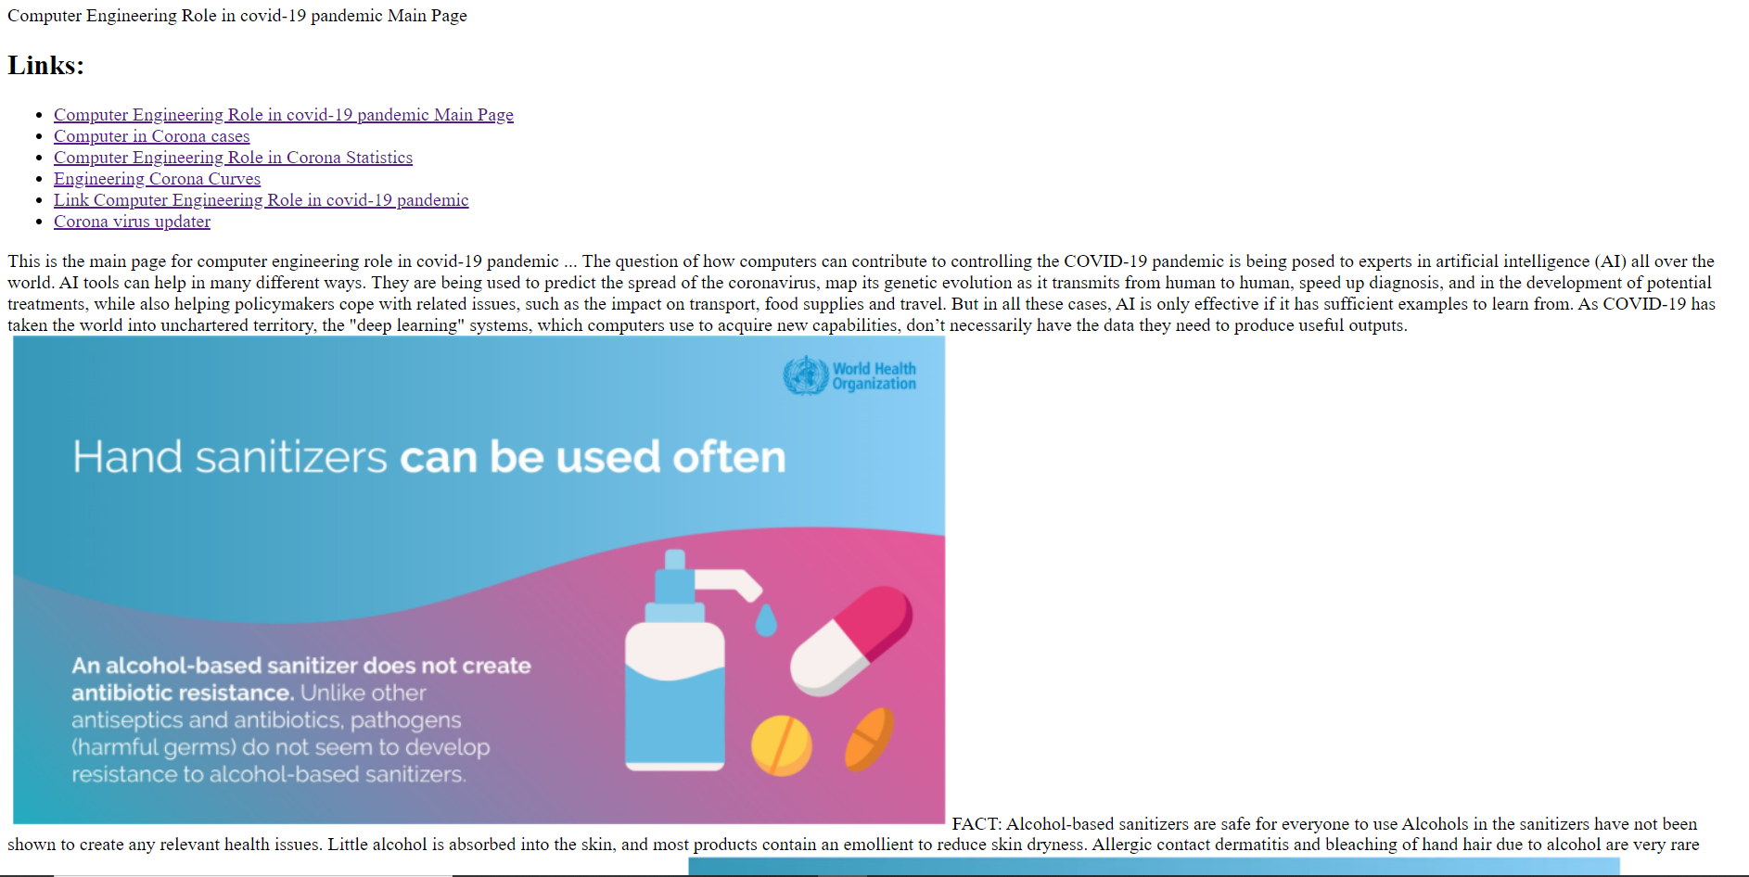

Link source

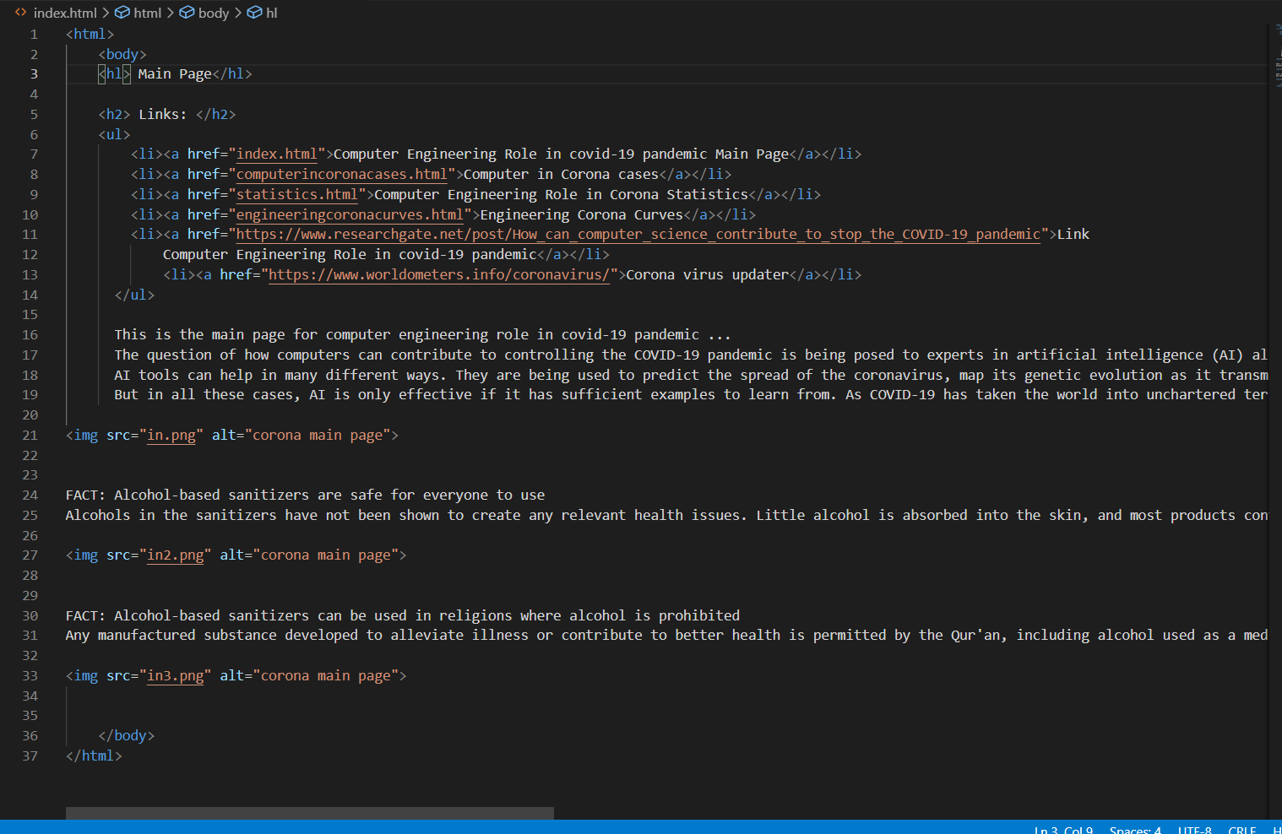

## Html code [computer in corona cases]

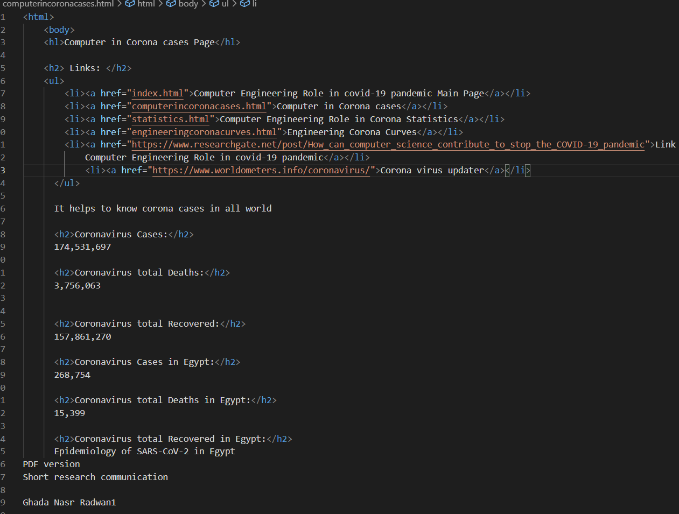

## Html code [computer ienginering in corona sttistics ]

Link source